NIP Project — Submission Template
Pega Platform project · This document is your complete submission
Read this before you start:
1. Fill in Section 1 completely. The Pega application name must follow the format NIP-[Project]-[YourName].
2. Create a new Operator in Pega with your full name and log in as that operator before taking any screenshot.
3. When you create your test case, enter YOUR FULL NAME in the Issue Description (Vehicle) or Movie Name (Movie) field.
4. Complete only the section for your chosen project. Delete the other project section.
5. Paste one screenshot per user story (10 total). Follow the screenshot rules in your selected project section.
6. Answer every question in Sections 3 and 4 in your own words.
7. Save the file using this format: ProjectName_FirstName_LastName.docx. Use VehicleService or MovieTicket as the ProjectName. Examples: VehicleService_Ravi_Kumar.docx or MovieTicket_Ravi_Kumar.docx.

Section 1 — Your Details
Full Name | Rajat Sharma
Email ID (registered on NIP) | rajatbhardwaj6247@gmail.com
Phone Number | 8708526247
College Name | St.Andrews Institute of Technology and Management
Course (e.g. IT, CS) | BCA
State | Haryana
Project Chosen (Vehicle Service OR Movie Ticket Booking) | Vehicle Service
Pega Application Name (e.g. NIP-VehicleService-YourName) | Vehicle Service Management_RajatSharma
Case Type Name (exact) | Vehicle intake
Pega Instance URL | https://u83tjoyp.pegaacademy.net/prweb/app/vechile-service-management/hvcpWh0V8YahOwtpkcPzn1MihCxH7XPi*/!STANDARD?pzuiactionzzz=CXtycX04YmY5MmFkNWNjYmZjOWVlNGYzZGViZTcyMTI0YmZhYzFmNmQwZGQ0YjJiNDkyYjI2MTU1YzhlOTkyNzNiMTQzYWJiYzJmMTUyMDM0OWYxNTY0MmUzYzg2YjQwMjhmZDg=*
Operator Name (created in Pega with your full name) | RajatSharma

Section 2A — Vehicle Service Management Application
Complete this section only if you selected this project. Delete the other project section before submitting.

Screenshot rules — IMPORTANT before you start:
1. Name your Pega application as: NIP-VehicleService-YourName OR NIP-MovieTicket-YourName
2. Create a new Operator in Pega with your full name (Security → Operators) and log in as that operator.
3. When you create your test case, enter YOUR FULL NAME in the Issue Description (Vehicle) or Movie Name (Movie) field.
4. The logged-in operator name must be visible in every screenshot wherever the Pega interface displays it.
5. The student's full name must be visible in all running-case screenshots.
6. Configuration screenshots must clearly show the relevant application or rule name.
Screenshots that do not show these will not be accepted.

US-001 — Submit Vehicle Service Request
What is expected:
Case created, customer submits Vehicle ID, Vehicle Model, Issue Description. Validation applied.
Screenshot — paste your screenshot below this line:
[ Paste screenshot here - follow the screenshot rules above ]
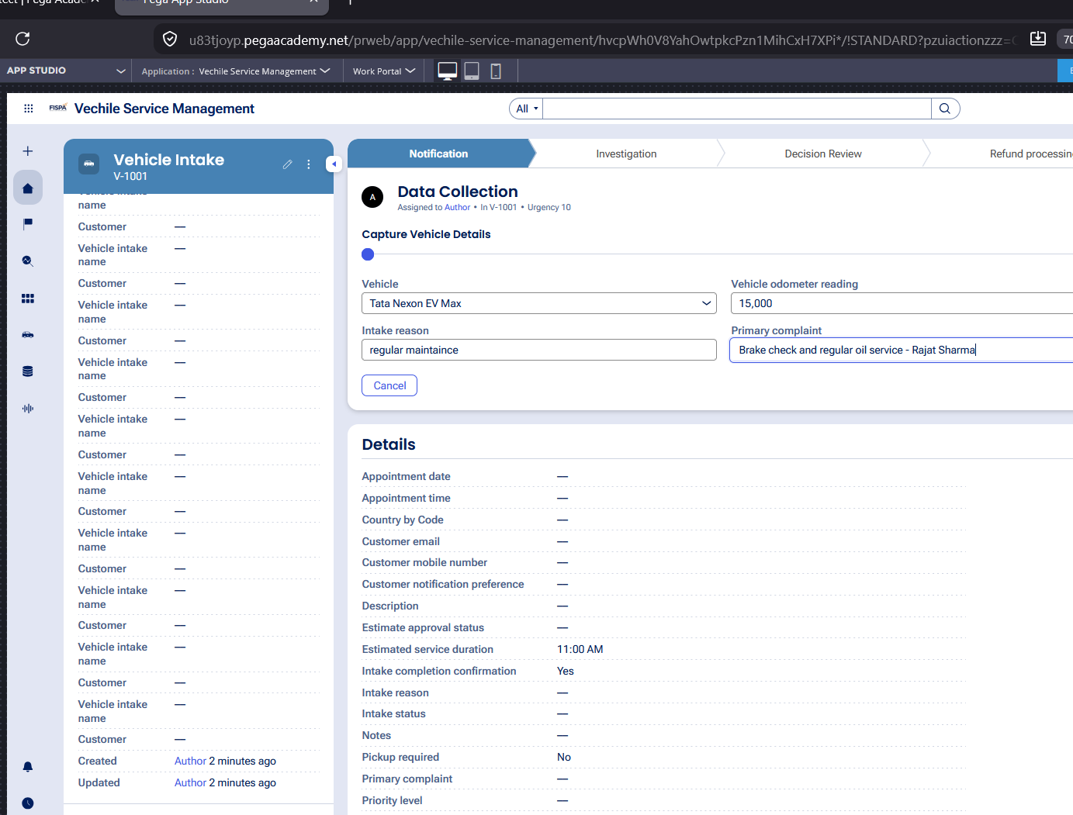

What I built for this (1–2 lines in your own words):
Configured a Collect Information step in the intake stage with fields to capture vehicle details, customer information, odometer reading, and primary service complaints

US-002 — Perform Vehicle Inspection
What is expected:
Inspection stage with Service Advisor step. Inspection Notes and Condition Rating captured.
Screenshot — paste your screenshot below this line:
[ Paste screenshot here - follow the screenshot rules above ]

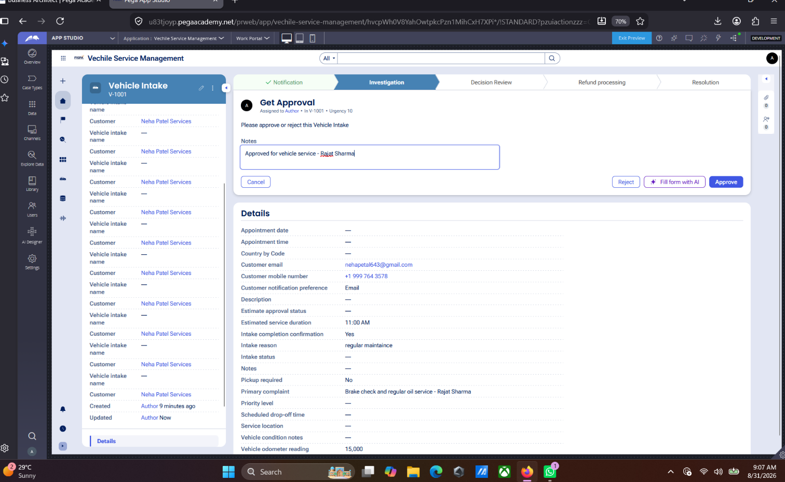

What I built for this (1–2 lines in your own words):
Created an inspection step for the Service Advisor to record inspection findings, notes, and vehicle condition rating.

US-003 — Generate Service Estimate
What is expected:
Labor Cost and Parts Cost captured. Total Cost calculated automatically by declare expression.
Screenshot — paste your screenshot below this line:
[ Paste sc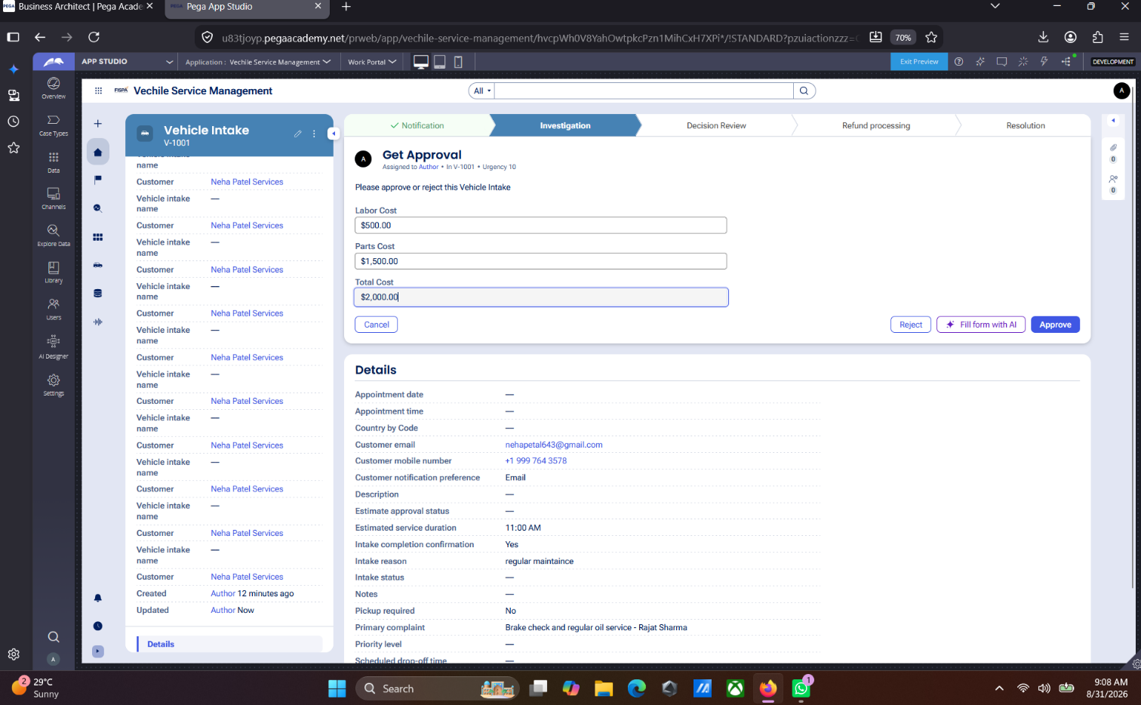reenshot here - follow the screenshot rules above ]

What I built for this (1–2 lines in your own words):
Configured currency fields for labor and parts costs and implemented an automated calculation rule for Total Cost.

US-004 — Approve Service Estimate
What is expected:
Approval stage assigned to Customer. Approval Status captured. Flow branches on approve/reject.
Screenshot — paste your screenshot below this line:
[ Paste screenshot here - follow the screenshot rules above ]

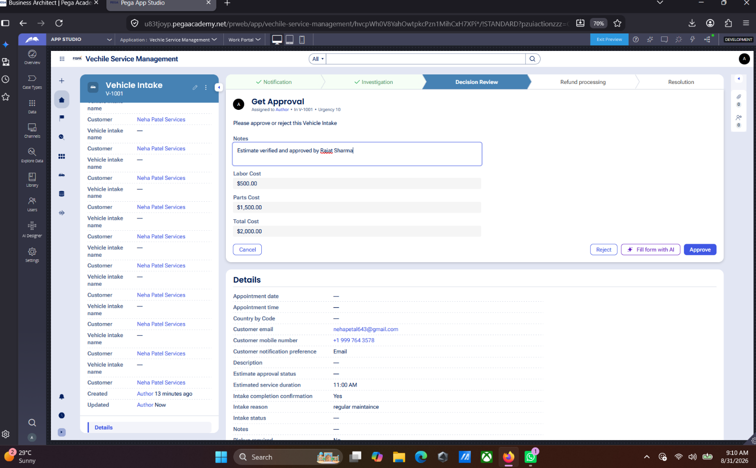

What I built for this (1–2 lines in your own words):
Configured an Approve/Reject step to route the cost estimate to the customer for review and decision.

US-005 — Maintain Vehicle Data
What is expected:
Reusable Vehicle data object created with Vehicle ID, Model, Type — linked to case.
Screenshot — paste your screenshot below this line:
[ Paste screenshot here - follow the screenshot rules above ]
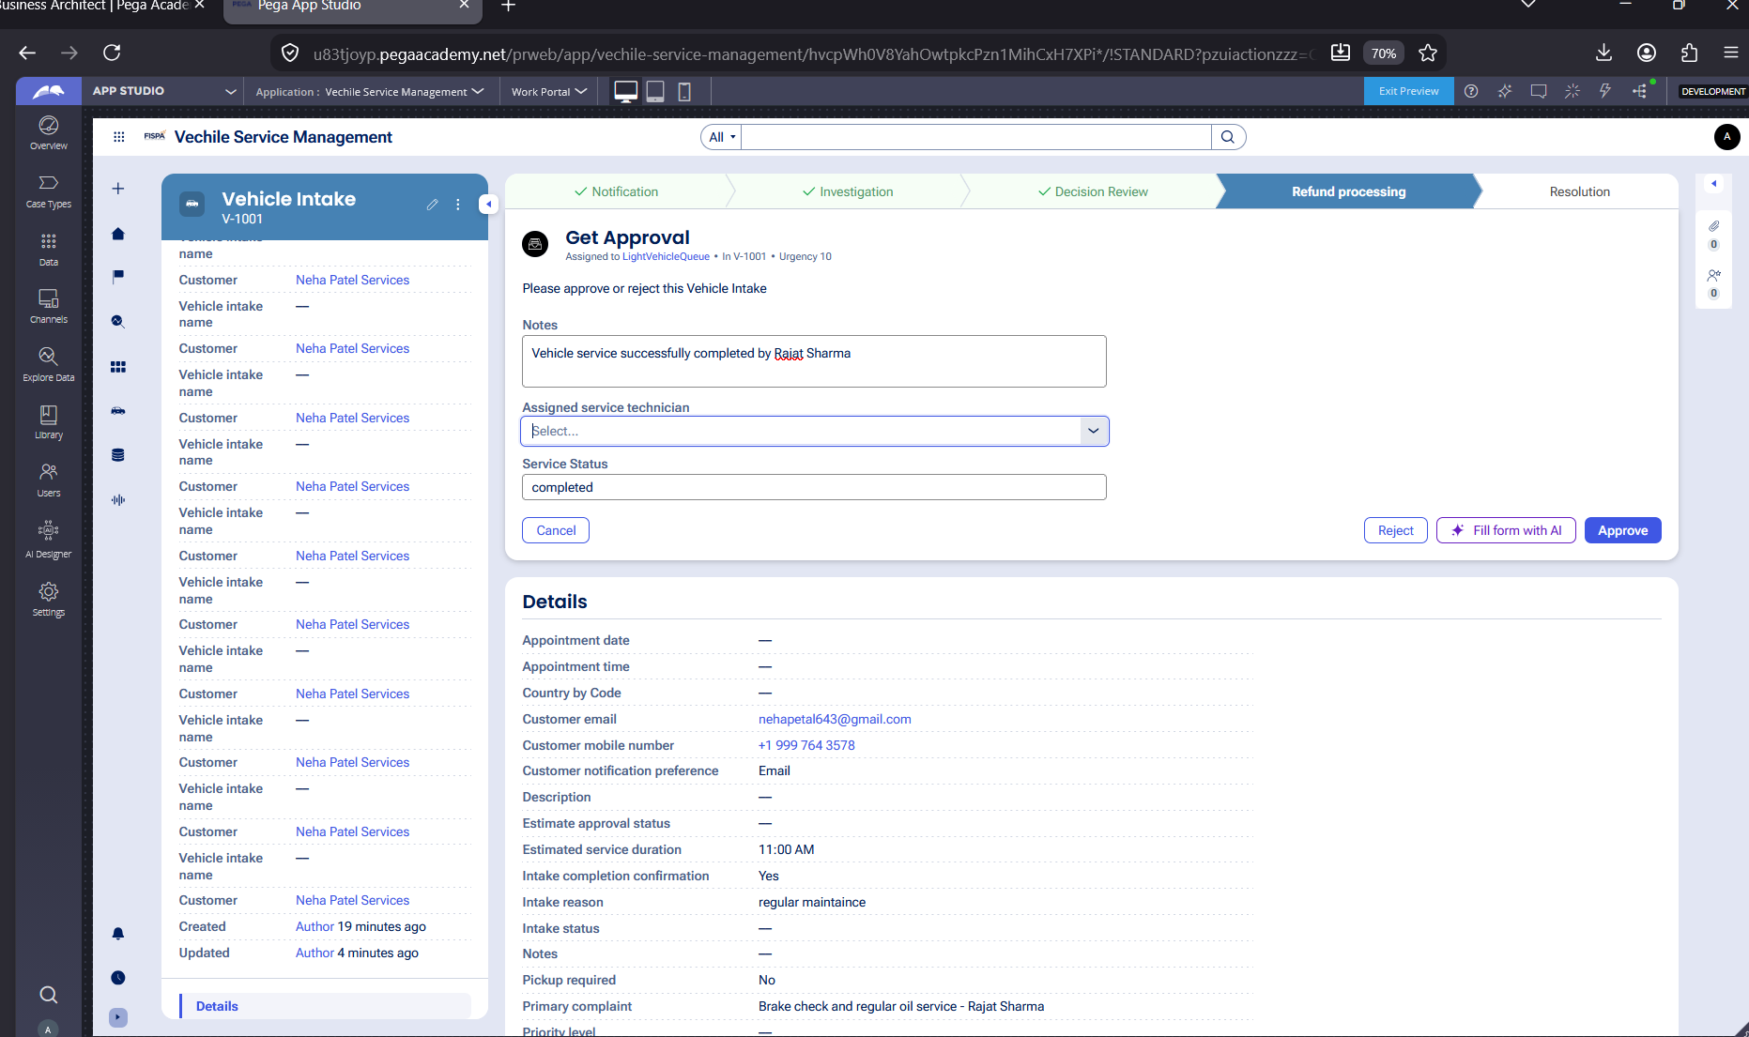

What I built for this (1–2 lines in your own words):
Created a reusable Vehicle Data Object with fields for Vehicle ID, Make, Model, and Vehicle Type.

US-006 — Review Service Estimate
What is expected:
Approval screen shows Labor Cost, Parts Cost and Total Cost clearly to the Customer persona.
Screenshot — paste your screenshot below this line:
[ Paste screenshot here - follow the screenshot rules above ]


What I built for this (1–2 lines in your own words):
Designed a read-only review view displaying the detailed breakdown of labor, parts, and total service costs for customer review.

US-007 — Auto Assign Technician
What is expected:
Service Execution stage with routing to HeavyVehicleQueue or LightVehicleQueue. Assigned Technician and Service Status properties maintained.
Screenshot — paste your screenshot below this line:


What I built for this (1–2 lines in your own words):
Configured an execution assignment to capture service technician details, notes, and update service status to Completed.

US-008 — Notify Service Completion
What is expected:
Correspondence rule created and triggered on case resolution. Email includes case and vehicle details.
Screenshot — paste your screenshot below this line:
[ Paste screenshot here - follow the screenshot rules above ]
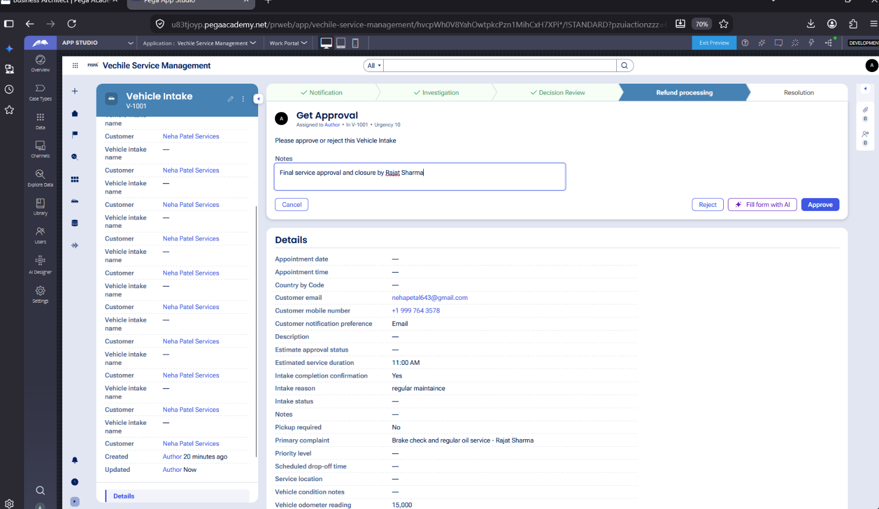

What I built for this (1–2 lines in your own words):
Configured an automated Send Email step using a dynamic message template containing case details to notify the customer upon service completion.

US-009 — Define Service SLA
What is expected:
SLA configured on the case type. Goal: 2 days. Deadline: 3 days. Priority increases on breach.
Screenshot — paste your screenshot below this line:
[ Paste screenshot here - follow the screenshot rules above ]

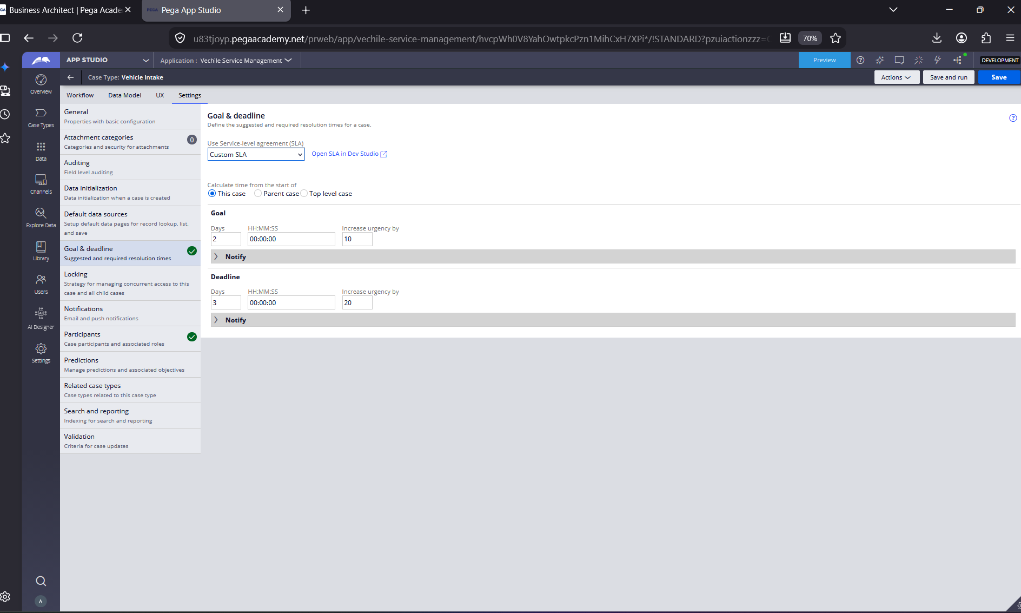

What I built for this (1–2 lines in your own words):
Configured a case-level SLA in Settings with a 2-day Goal and a 3-day Deadline to automatically increase case urgency if resolution is delayed.

US-010 — Route by Vehicle Type
What is expected:
Routing rule or Decision Table routes to HeavyVehicleQueue or LightVehicleQueue based on Vehicle Type property.
Screenshot — paste your screenshot below this line:
[ Paste screenshot here - follow the screenshot rules above ]
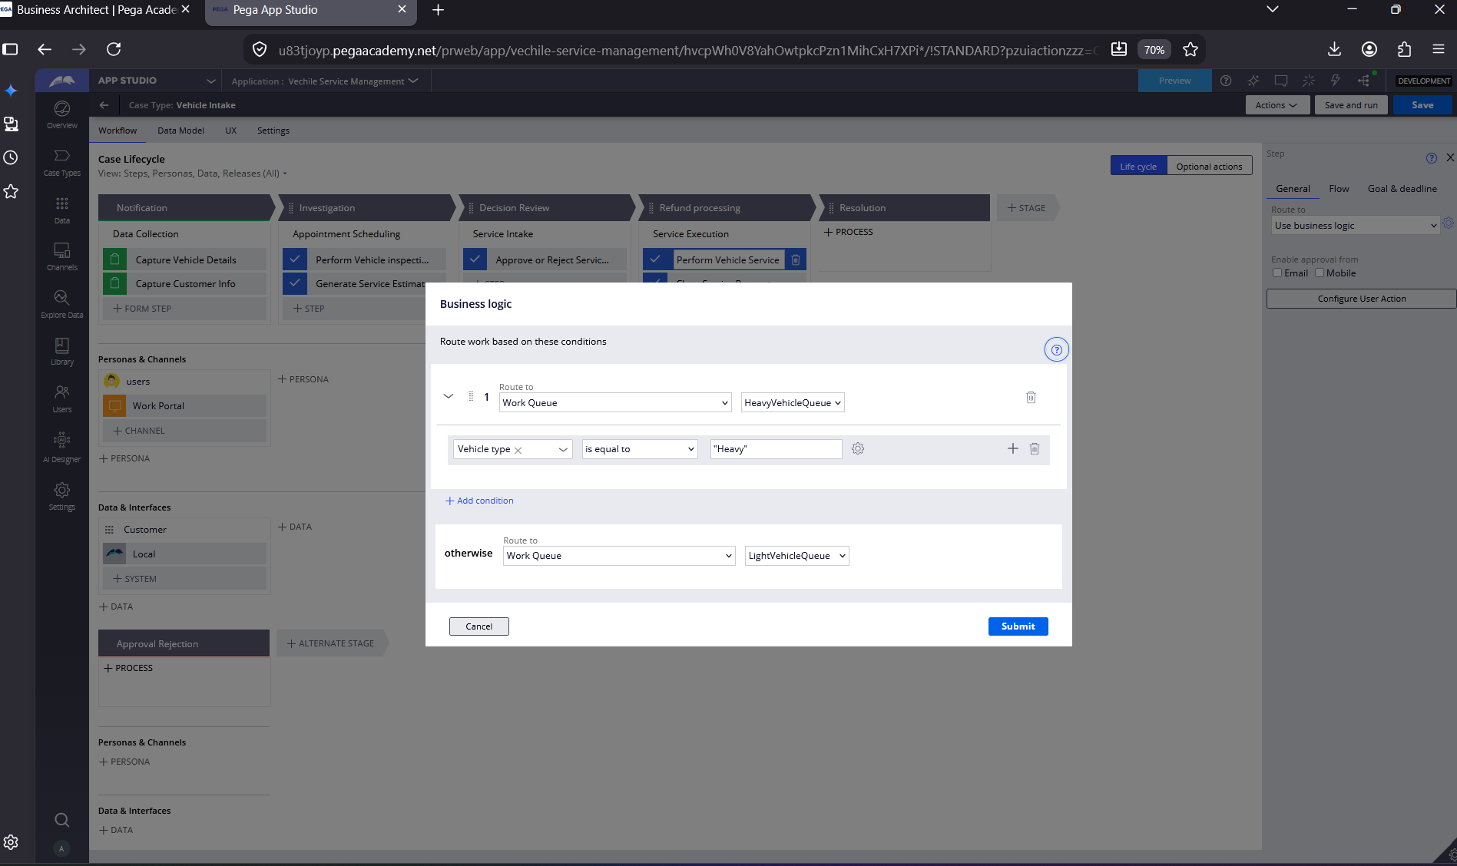

What I built for this (1–2 lines in your own words):
Implemented business logic routing based on vehicle type to route heavy vehicles to HeavyVehicleQueue and other vehicles to LightVehicleQueue.

Section 2B — Movie Ticket Booking Management Application
Complete this section only if you selected this project. Delete the other project section before submitting.

Screenshot rules — IMPORTANT before you start:
1. Name your Pega application as: NIP-VehicleService-YourName OR NIP-MovieTicket-YourName
2. Create a new Operator in Pega with your full name (Security → Operators) and log in as that operator.
3. When you create your test case, enter YOUR FULL NAME in the Issue Description (Vehicle) or Movie Name (Movie) field.
4. The logged-in operator name must be visible in every screenshot wherever the Pega interface displays it.
5. The student's full name must be visible in all running-case screenshots.
6. Configuration screenshots must clearly show the relevant application or rule name.
Screenshots that do not show these will not be accepted.

US-001 — Submit Movie Ticket Request
What is expected:
Case created, customer submits Movie Name, Show Date, Show Time, Number of Tickets. Validation applied.
Screenshot — paste your screenshot below this line:
[ Paste screenshot here - follow the screenshot rules above ]

What I built for this (1–2 lines in your own words):
[ Type here ]

US-002 — Check Show Availability
What is expected:
Availability stage. Seat Availability Status and Available Seats Count captured. Booking proceeds only if available.
Screenshot — paste your screenshot below this line:
[ Paste screenshot here - follow the screenshot rules above ]

What I built for this (1–2 lines in your own words):
[ Type here ]

US-003 — Calculate Booking Cost
What is expected:
Total Cost calculated automatically from Ticket Price and Number of Tickets using a business rule.
Screenshot — paste your screenshot below this line:
[ Paste screenshot here - follow the screenshot rules above ]

What I built for this (1–2 lines in your own words):
[ Type here ]

US-004 — Confirm Booking Request
What is expected:
Approval stage assigned to Customer. Booking Status captured. Flow branches on confirm/cancel.
Screenshot — paste your screenshot below this line:
[ Paste screenshot here - follow the screenshot rules above ]

What I built for this (1–2 lines in your own words):
[ Type here ]

US-005 — Maintain Movie and Show Data
What is expected:
Reusable Movie and Show data objects created with Movie Name, Genre, Show Date, Show Time, Seat Capacity — linked to case.
Screenshot — paste your screenshot below this line:
[ Paste screenshot here - follow the screenshot rules above ]

What I built for this (1–2 lines in your own words):
[ Type here ]

US-006 — Review Booking Details
What is expected:
Confirmation screen shows Movie Name, Show Timing, Number of Tickets and Total Cost clearly.
Screenshot — paste your screenshot below this line:
[ Paste screenshot here - follow the screenshot rules above ]

What I built for this (1–2 lines in your own words):
[ Type here ]

US-007 — Process Ticket Booking
What is expected:
Booking Execution stage. Seat Numbers, Ticket ID and Booking Confirmation Status maintained.
Screenshot — paste your screenshot below this line:
[ Paste screenshot here - follow the screenshot rules above ]

What I built for this (1–2 lines in your own words):
[ Type here ]

US-008 — Notify Booking Confirmation
What is expected:
Correspondence rule triggered on case resolution. Email includes movie, show, seat and cost details.
Screenshot — paste your screenshot below this line:
[ Paste screenshot here - follow the screenshot rules above ]

What I built for this (1–2 lines in your own words):
[ Type here ]

US-009 — Define Booking SLA
What is expected:
SLA configured on the case type. Goal: 1 day. Deadline: 2 days. Priority increases on breach.
Screenshot — paste your screenshot below this line:
[ Paste screenshot here - follow the screenshot rules above ]

What I built for this (1–2 lines in your own words):
[ Type here ]

US-010 — Route by Show Type
What is expected:
Routing rule or Decision Table routes to PremiumShowQueue or StandardShowQueue based on Show Type property.
Screenshot — paste your screenshot below this line:
[ Paste screenshot here - follow the screenshot rules above ]

What I built for this (1–2 lines in your own words):
[ Type here ]

Section 3 — About Your Application
These answers are checked against your screenshots. Write exactly what is in your application.

Q1. List your stages in the order they appear in your case lifecycle.
Stage names in order, separated by commas.
Notification, Investigation, Decision Review, Refund processing, Resolution

Q2. Name the data object(s) you created and the properties inside them.
Data object name and its properties.
Vehicle (Properties: Vehicle ID, Vehicle Model, Vehicle Type)

Q3. What is the exact name and type of the rule you used to calculate Total Cost?
Provide:
• Rule Name
• Rule Type
• Properties used in the calculation
• Formula used
* Rule Name: TotalCost (Declare Expression)
* Rule Type: Expression / Calculated Field
* Properties used in the calculation: LaborCost, PartsCost
* Formula used: TotalCost = LaborCost + PartsCost

Section 4 — Your Understanding
Short, honest and specific answers score well.

Q4. What did Blueprint generate for you, and what did you add or change yourself afterwards?
Be specific about what was already there and what you built or modified on top.
Blueprint generated the base case lifecycle stages, basic steps, and standard fields. Afterwards, I manually configured the Total Cost calculation expression (Labor Cost + Parts Cost), setup custom case-level SLA with Goal and Deadline urgency rules, implemented business logic routing based on vehicle type to route cases to HeavyVehicleQueue and LightVehicleQueue, and configured the automated completion email notification step.

Q5. Was there anything Blueprint created that you had to correct or configure further? Describe one example.
A real example from your own work.
Yes, the work routing logic was not configured by default. I had to open the service execution assignment step and configure custom Business Logic routing so that if the Vehicle Type is equal to "Heavy", the case routes to HeavyVehicleQueue, and otherwise it routes to LightVehicleQueue.

Q6. Explain your case flow from creation to resolution, in order.
What happens first, who does what, when the case closes.
1. Creation / Intake: The customer or advisor submits the service request with vehicle details, issue description, and customer contact information.
2. Inspection & Estimation: The advisor performs an initial vehicle inspection, inputs labor and parts costs, and the system automatically calculates the Total Cost.
3. Approval: The cost estimate is routed to the customer, who reviews the breakdown and approves the request.
4. Execution & Routing: Based on the vehicle type, the case is routed to the appropriate work queue (HeavyVehicleQueue or LightVehicleQueue) where a technician performs the service and marks it completed.
5. Resolution: The case triggers an automated email notification to the customer with full service details and resolves successfully.

Q7. Pick two design choices you made in your application and explain why you made them.
For each design choice, provide:
• What you implemented
• Why you chose that approach
• What benefit it provides to the application
* What you implemented: Automated calculation expression for Total Cost (LaborCost + PartsCost).
* Why you chose that approach: To eliminate manual calculation errors by service advisors and ensure instant updates whenever cost fields change.
* What benefit it provides to the application: Ensures 100% pricing accuracy, transparency for customer review, and speeds up the estimation process.

Q8. What was the hardest part, and how exactly did you fix it?
Specific and honest. A real challenge scores much better than a generic answer.
The hardest part was setting up the conditional business logic routing for work queues in App Studio. Finding the specific data property nested inside the Vehicle data object hierarchy required properly navigating the property picker. I resolved it by selecting the Vehicle data reference from the context picker, locating the "Vehicle type" text property, and configuring the condition (is equal to "Heavy") to route to HeavyVehicleQueue, while setting the fallback "otherwise" action to LightVehicleQueue.

Q9. If the approval step was only needed when Total Cost is above a certain amount, what would you change in your application?
Explain what you would change and where. You do not need to build this.
I would open the Approval step configuration in App Studio or Dev Studio and add a skip/run condition. Specifically, under the step's "Condition" settings, I would set it to run only when "TotalCost is greater than [Threshold Amount]" (for example, TotalCost > 1000). If the condition evaluates to false, the workflow will automatically skip the approval assignment and proceed directly to service execution.

Q10. List three exact rule names from your application that you personally created or modified.
Include the rule name and rule type for each one (for example: CalculateTotalCost - Declare Expression).
1. TotalCost - Declare Expression / Calculated Field
2. HeavyVehicleQueue - Work Queue
3. ServiceCompletionEmail - Send Email / Message Template

Q11. List all personas used in your application.
List the persona names exactly as they appear in your application.
Customer, Service Advisor, Technician

Q12. List all work queues used in your application and explain when each one is used.
For each work queue, provide its exact name and the condition or type of work routed to it.
1. HeavyVehicleQueue: Used when the Vehicle Type property equals "Heavy", routing high-capacity and commercial vehicle jobs to specialized heavy vehicle mechanics.
2. LightVehicleQueue: Used as the default fallback queue ("otherwise" condition) for all other standard cars, sedans, and light vehicles.

Before You Submit — Check These
Read through once before uploading.
1. Section 1 filled in. Application named as NIP-[Project]-[YourName]. Names match the actual application.
2. New Operator created in Pega with my full name. I logged in as that operator for all screenshots.
3. Only my chosen project section remains — the other project section is deleted.
4. All 10 user story screenshots are pasted and follow the operator, running-case, application, and rule-name evidence requirements.
5. Every question in Sections 3 and 4, including Q10, Q11, and Q12, is answered in my own words.
6. This file is named using the required format: ProjectName_FirstName_LastName.docx (for example, VehicleService_Ravi_Kumar.docx or MovieTicket_Ravi_Kumar.docx) and uploaded as required.

